Activity 5.2 Applying Learning Analytics in your course
Aim: Investigate Learning Analytics available in your own LMS or Moodle.
Task: Plan to apply Learning Analytics in your course.
- Browse through some of the Learning Analytics available in Moodle using the resource links above (or do the same within your own LMS)
- Choose one particular LA function available to reflect on
- Plan how you could apply this in your own course, making sure to highlight the associated benefits.

Learning analytics (LA) is the collection and analyzing of learners data as obtained from the LMS such as Moodle. This data can predict the behaviour of learners and the related learning outcomes. They also form a base of improving the learning environment. Different data can be collected from the moodle LMS. For example from the course report one can generate activity logs, activity report, live logs, participation reports and events report for both the teachers and students. In the moodle, this functionality of report icon is found under the settings, course administrator then reports. Under the reports, there exist logs, live logs, course participation and activity report. Thus course action can be filtered by user, date, resource / activity and action.
The LA selected in this assignment to reflect upon are Logs as activity reports. Logs can be filtered by the teaching level and participation level. I will focus on logs at the students level thus analyzing individual action, event and participation in moodle and how it can be related to a user’s learning experience. Such actions may involve students posting into a forum or submitting an assignment. I will manage to see the pages students accessed, the time and date they accessed the LMS, the IP address they came from, and their actions (if they only viewed the information, added something new, update some information or delete some). The IP address link provides an estimate of the student's location.
The table below reflects the student log report.
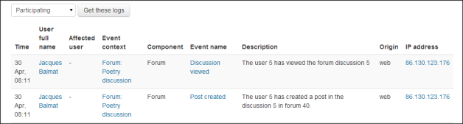
The associated benefits of the LA are that, student’s logs can be displayed on a page or download in a text or Excel format. As well, the log report page contains active links thus enabling the user to access a student's profile page or a particular page that the student was viewing.
Based on this data obtained, it can be possible to establish the relation between student’s participation (in terms of participation in forum/s, timely submission of assignments, actions done online and the number of times the student participated / accessed the LMS) and the learning outcomes. Thus a learning outcome can become the function of any these reports generated from the moodle LMS.

